Data Networks
K.J.Blow, 1999
Sample Problems 2.
- Compare and contrast connectionless and connection-orientated routing.
- State the optimality principle for routes and explain why it is true.
- The network below has route lengths as defined in the table. A) Draw the sink tree for node E given the definition that the optimum route has the shortest length. B) Draw the sink tree for node E given that the optimum route has the minimum number of hops, where two route have the same number of hops choose the route with the shortest length.
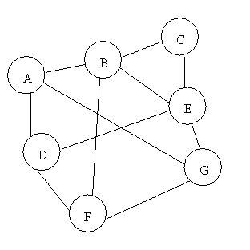 | Route Length  A-B 1  A-G 4  A-D 1  B-C 1  B-E 3  B-F 3  C-E 1  D-E 3  D-F 1  E-G 1  F-G 2
- Describe the Dijkstra algorithm for finding optimal routes on a network and explain how it could be implemented as a distributed route finding algorithm. Discuss the various factors that could be allowed for in defining a route penalty function.
- Describe the distance vector routing algorithm and explain the count to infinity problem.
- Describe how routing is performed using link state algorithms.
- Define congestion. Discuss the difference between open loop control and closed loop control mechanisms for dealing with congestion.
- Discuss the concept of choking as a congestion control mechanism.
- Describe tunnelling and explain why it is specifically allowed for in the OSPF routing protocol.
- Explain the process of packet fragmentation. Discuss both transparent and non-transparent fragmentation.
- Describe the purpose of the border gateway protocol used on the Internet. How does it avoid the ‘count to infinity problem’.
- Discuss the main differences between the network and transport layers.
- Describe a simple set of transport layer primitives and how they are used.
- Define a transport service address point and discuss ways in which they are managed. How do the requirements differ for a server and a client.
- Discuss the purpose of sequence numbers in setting up a connection. Why are clock based schemes preferred.
- Why does flow control have to happen more than once.
- Describe TCP buffering management and how an application can modify its behaviour.
- Describe Nagel’s algorithm for flow control and why it is necessary.
- Describe the TCP congestion control mechanism.
- Why are cipher chaining and byte feedback mode used to augment cryptographic ciphers.
- What is the point of public key cryptography? How does it work?
- Describe authentication and digital signatures.

